**WordPress Self-Tutorial**Writing a PostWordPress Version 4.1.1

*In this session, you will learn how to add, edit, and publish a new post and a new page. And you’ll discover what makes them different.*

After you have logged into the practice site, you will be in the Dashboard. This is the administrative (private) side to the WordPress site. Only logged in users can see the dashboard. You will be working with two areas of the dashboard: Posts and Pages.

**Posts**

Posts, or blog posts, are the standard way to publish new content to your WordPress website. Post can contain text, images, tags, and categories. They can be drafted in advance of publishing.

Click on Posts to view all existing posts and to start writing a new post.

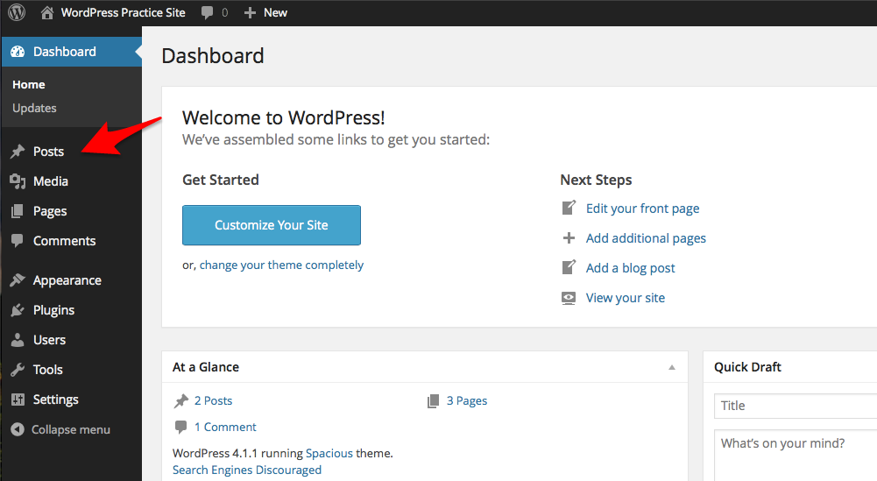

From posts you can search for, edit, and delete any existing posts or start writing a new post. Click on “Add New.”

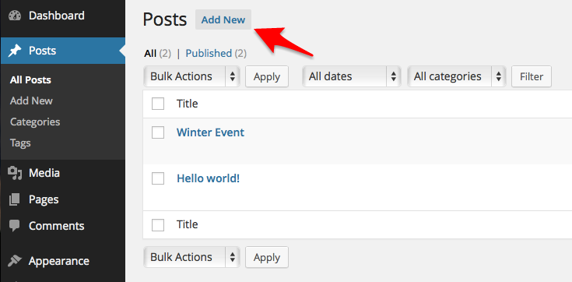

**Writing Your First Post**

Writing a blog post is similar to writing a news article. You will need an informative title and interesting content to share. Make sure you are writing in the “Visual” tab. (The “Text” tab is for writing/tweaking HTML code.)

**Getting to Know the Post Toolbar**

Put your mouse over the various toolbar buttons situated between the title and post content to receive a hint as to their function. You should find that most are similar to any word processing software. Be sure to click on the “Toolbar Toggle” button to view more buttons.

*Hint: Avoid adding special formatting or colors to your post. Instead, let the site’s theme dictate the look of the posts.*

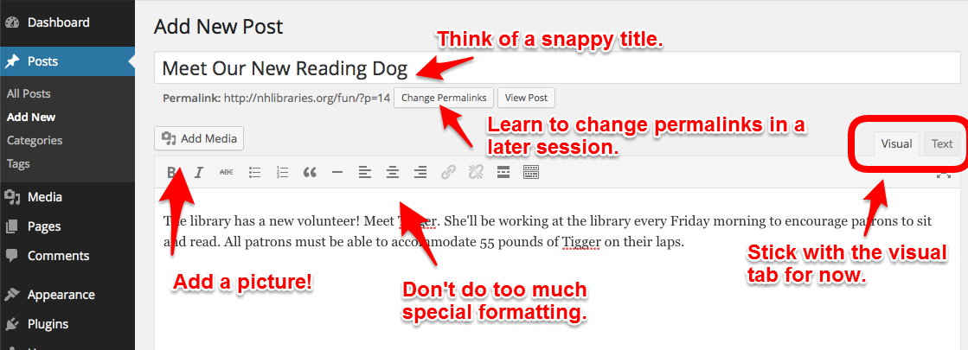

Once you have written your post, place your cursor before the first word of text in your post and click “Add Media.”

Upload a photo from your own computer or use one of the existing photos already uploaded to our practice site (Media Library).

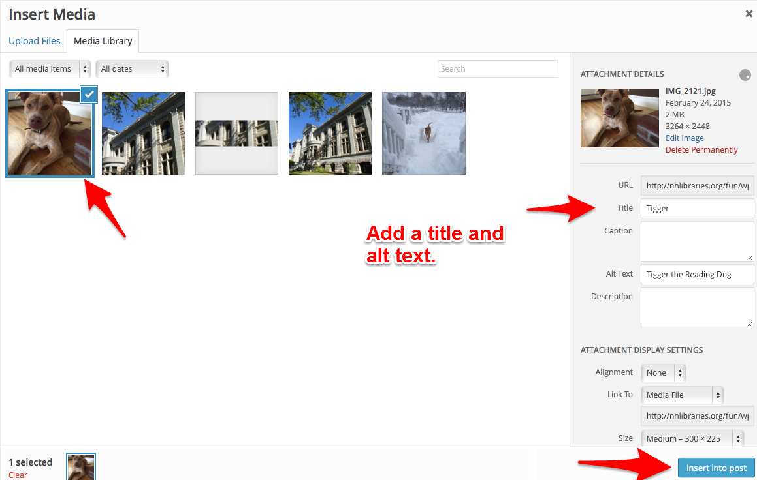

Click once on the photo to change its alignment.

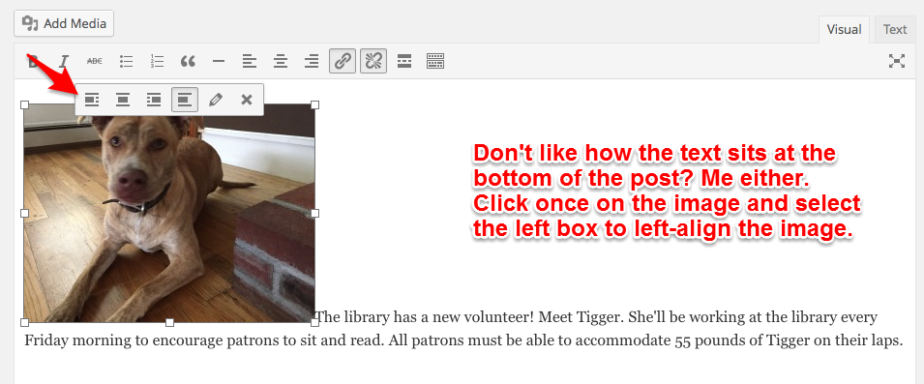

This is better!

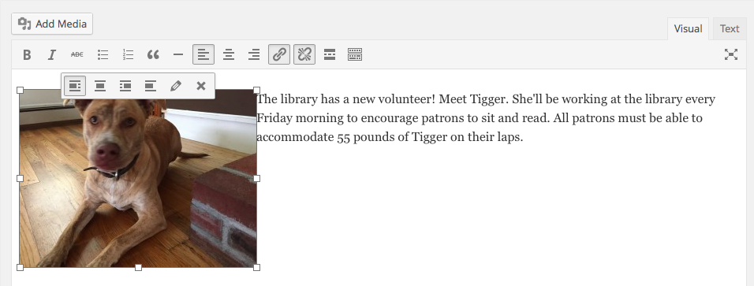

**Add an External Link to the Image**

It is possible to link the image to another webpage. This might be helpful if you are promoting a library database or directing patrons to another page on your site. To change the link, click on the photo one time, click on the pencil, and change the link from a “Media File” to “Custom URL,” and write/paste your desired webpage.

**Adding an External Link to the Text in the Post**

To add a link to a word or phrase, simply highlight the word/s, click on the small link button and type or paste in the desired link. Note that the word or phrase must be highlighted before the link button can be used.

**Using Categories to Build Site Navigation**

With WordPress, the categories -- and to some extent the tags -- create the navigation structure of the site. This is a terrific feature! When you apply a category to a post, the post is automatically part of the navigation structure. We’ll learn how to add categories to the site menu (or navigation structure) in upcoming weeks.

**Categories v. Tags**

Categories are used to group posts into wide subjects. Most themes use categories to build the navigation structure. For this reason, you’ll want to consider the use of categories very carefully to avoid unnecessary duplication.

Tags are used to link specific topics together. You can use tags liberally to help your readers find similar news.

**Applying an Existing Category**

By default, existing categories are listed and easily selected by the post’s author. Posts can have one or more categories. For the sake of site navigation, you will want to think about the categories that make up your site. This can be one of the harder tasks in building your new site! My advice would be to start with only a few categories and add more only when they are needed.

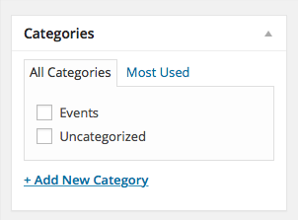

**Adding a New Category**

Adding a new category is as easy as clicking the link “Add New Category.” For this reason, speak to your co-authors about the importance of using existing categories or install a plugin that restricts specific user roles to using existing categories only.

It is rarely necessary to deal with parent or child categories in new versions of WordPress. Simply make all categories “Parent Categories.”

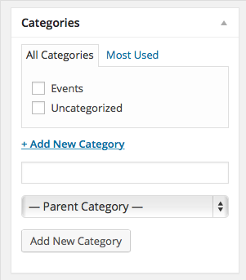

**Adding Tags**

As tags are rarely used to build the site navigation, you can use tags very liberally. However, always use existing tags whenever possible to avoid too many similar tags. Click on the link “Choose from the most used tags” to show a small tag cloud of exiting tags to use. Existing tags will also appear when typing in a tag. New tags can be typed in as desired.

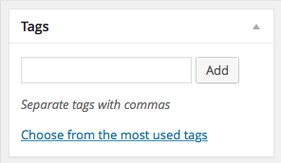

**Discovering Publishing Options**

Before a post is published to the website, it is a draft. Once it is published, it can be further editing and changed back to a private draft. A post can also be written – and kept as a draft – until a specific date. This is helpful when you need to advertise an event, but don’t have time to write up a new post when the public needs to learn about it. The preview button opens your post in a new tab or window to let you view your progress/layout.

Take a moment to click on the “Edit” links next to each of the options in “Publish” to learn more.

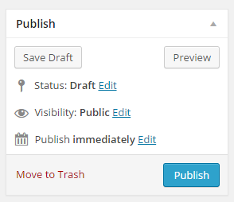

Publish your post to the word by clicking the “Publish” button when you are ready.

**Editing a Post**

Once the post has been published, it is possible to edit the post or put the post back to a draft (and hidden from the public). The editing option can be found as a small pencil icon from the public view of the post itself. (Don’t worry. Only logged in users can see the pencil.) The post can also be found in Dashboard >> Posts >> All Posts >> (Locate your post) >> Edit or Save as Draft.

**Great job!**

*Next week’s assignment will be learning when and how to add pages.*