**WordPress Self-Tutorial**When and How to Use PagesWordPress Version 4.1.1

*In this session, you will learn how to add, edit, and publish a new page. And you’ll discover what makes pages different from posts.*

After you have logged into the practice site, you will be in the Dashboard. This is the administrative (private) side to the WordPress site. Only logged in users can see the dashboard. You will be working with Pages.

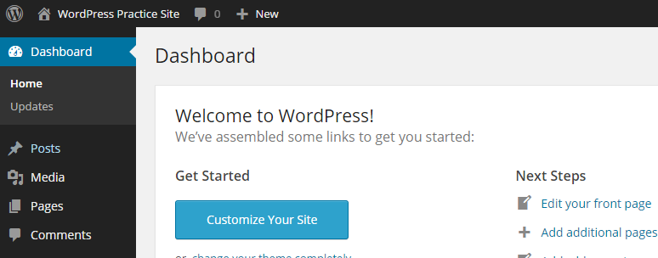

**Pages**

Pages look very similar to posts, but they serve a very different purpose and contain far fewer features. While posts make up ongoing sections of your site’s navigation, pages are static, stand-alone pieces of information that are manually linked within your site. Pages cannot be added to a category or contain tags. They are meant to contain pieces of information that do not change regularly, such as directions, contact staff, policies, etc. Pages can be manually added to the WordPress menu and be integrated seamlessly in your site. Pages will not be added to your blog page and cannot be received as updates by the patron via email or RSS reader. Some WordPress themes use pages in unique ways to display front page content.

**Adding a New Page**

To add a new page, visit >> Dashboard >> Pages >> Add New

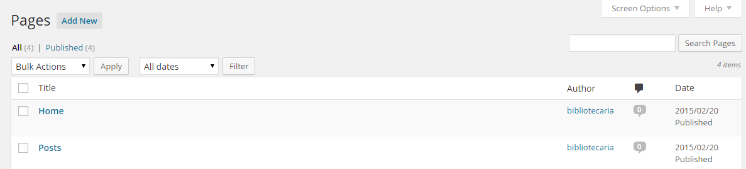

Notice that the new page and new post layouts are very similar. As a novice, you should take care to make sure that you are on the desired post/page!

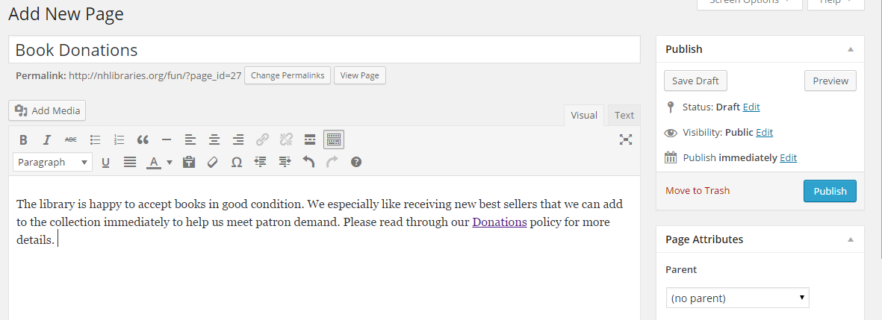

As with posts, you’ll want a clear, concise title and appropriate content. You will also find the same “Publish” options as available in posts. What is very different is the lack of categories or tags. Pages must be manually added to the site navigation structure to be discoverable by users.

**Assigning Page Attributes**

Some themes assign different templates to pages or allow you to choose a template for each page. It is best to leave the default template in place until the theme has been decided upon. The same can be said about any layout options.

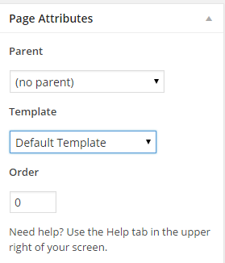 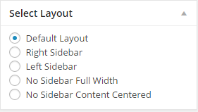

**When to Use Featured Images**

Knowing when to use and not use featured images is tricky. Some themes rely on featured images for homepage placement – but not all. It can also be difficult to determine the best size or shape for a featured image if you are working with a theme that lacks (free) documentation. The best thing to do is to experiment! Click on the link “Set Featured Image” to get started. Select an image…

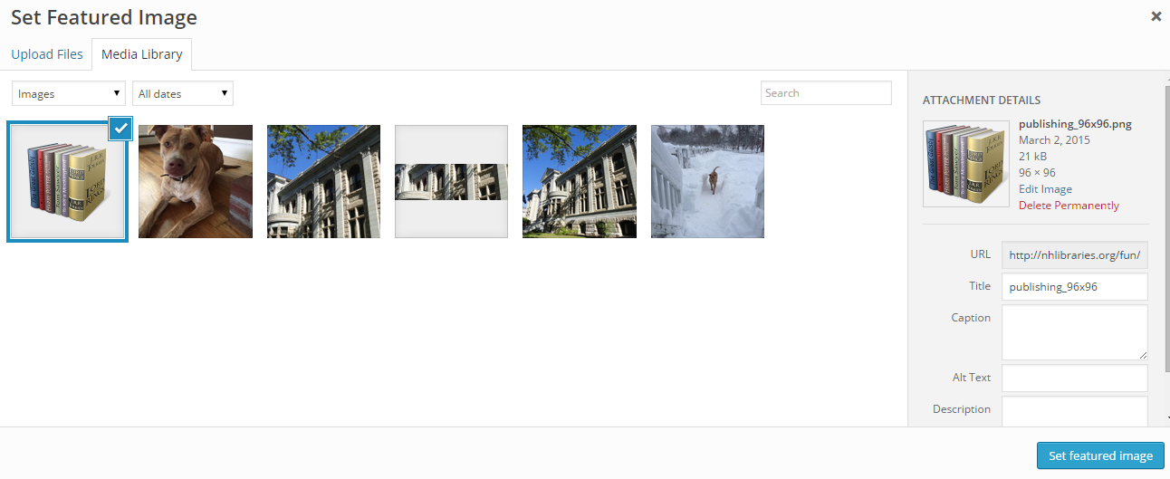

Now you should see…

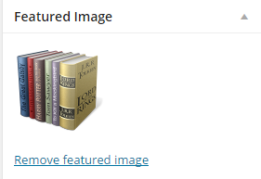

Now visit the newly published page and see what happens. In this case, the featured image did not show up in the page itself. Eventually, it was discovered that the featured image shows up when the page is used on a front page widget.

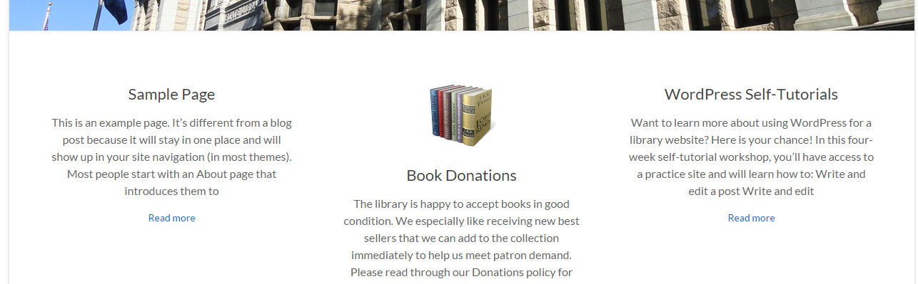

**Bonus Exercise**

Add a featured image to your page. Use one of the small images in the Media Library instead of loading one of your own. After adding the featured image, publish or update your page.

Return to the Dashboard >> Appearance >> Widgets >> Business Top Sidebar…

* Locate and expand TG: Services (a widget included in this theme)
* Use the dropdown to find and add your page to the homepage. (There are six available slots.)
* Save the widget changes and view the homepage.
* Hopefully, you now see your page and new featured image icon on the page.

**A Brief Explanation of Widgets**

Widgets bring additional – and optional – information to the WordPress site. There are a handful of widgets to choose from by default and many, many more that can be added to the site with the use of plugins. Typically widgets are “sidebar” widgets used to display recent posts or comments or categories, etc. to the site. However, more and more themes use widgets to add unique content to the site’s homepage.

**A Brief Explanation of Plugins**

Plugins bring additional functionality to the WordPress site. If you can think of it, a plugin has probably been created. Do you want an events-calendar that allows patrons to sign up for a program? Done! How about a way to keep your fellow librarians/authors from adding additional categories to your perfect WordPress site? It’s available! You can browse/search for plugins by visiting WordPress.org/plugins.

**Great job!**

*Next week’s lesson is the site menu.*