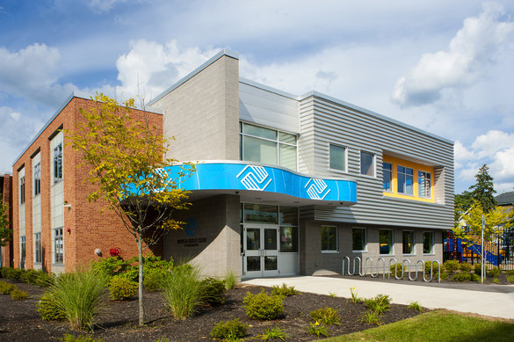
Hosted by: Center for
Autism and Related
Disorders (CARD)

For more information about
CARD please visit our website

centerforautism.com

Thursday, March 15th, 2018 at 5:30 PM
Manchester Boys and Girls Club
Free parent training

CARD is excited to be presenting free parent trainings in New Hampshire. Topics will focus on different aspects of Autism Spectrum Disorder. Children are more than welcome to join us! Our topic for March is…

"Understanding the Diagnosis of Autism”
A brief overview of diagnosis of autism, how this diagnosis is reached, and who can diagnose. The deficits that are common in individuals with autism will also be discussed.

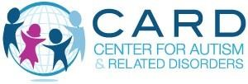 | Contact: Kelly Amlaw  ka6813@centerforautism.com

