2019 Visit with Smokey Bear
Application for NH public libraries
*Due Wednesday, May 1*

Library Name
Library Address
Library Telephone Number
Director Name
Director Email
Director’s Signature
Name and email of staff member who will coordinate the visit

Town / City Population
Total Summer Reading Program events & participants last year (2018)
Total attendance at Children’s Summer Reading Program events last year (2018)
Total planned Summer Reading Program events in 2019

Send application and questions to:
Capt. Doug Miner, N.H. Forest Protection Bureau
Email: douglas.miner@dncr.nh.gov
Phone: 603-227-8734

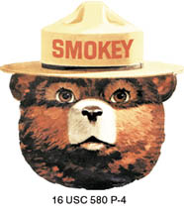
Please note: Due to Smokey Bear’s busy schedule, he will only be able to make visits to
five separate libraries as part of this program.

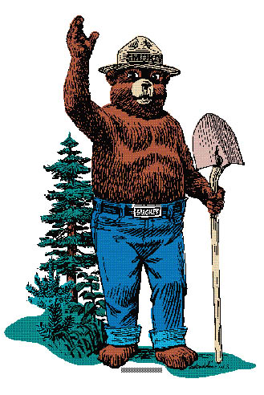
Library Visit with Smokey Bear
Application Form (p. 2)

Please answer the following questions:

- How would a Smokey Bear Library visit benefit your library patrons – not only young patrons – and your community as a whole?

- Smokey Bear’s mission is to help educate people of all ages about fire safety, with a special focus on wildfire prevention. How will you make the most of Smokey’s visit (special display, fire prevention programming, local firefighter involvement, etc.)?

- How do you plan to spread the word of Smokey Bear’s visit in advance and afterwards? Please list any special attendees (elected officials, local groups, etc.) you plan to invite.

- Please list 3 dates and event times in July that would be preferable if your library is chosen.
Preferred Date  & Time #1 |  | Preferred Date  & Time #2 |  | Preferred Date  & Time #3

