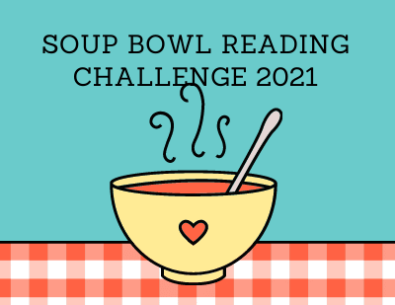

Instructions
Read a book that starts with each letter of the alphabet.

